FLASK
​Flask is a micro framework ​that can create web applications. ​It is not opinionated like ​some other larger frameworks and does ​not bind the user to a specific set of tools. ​
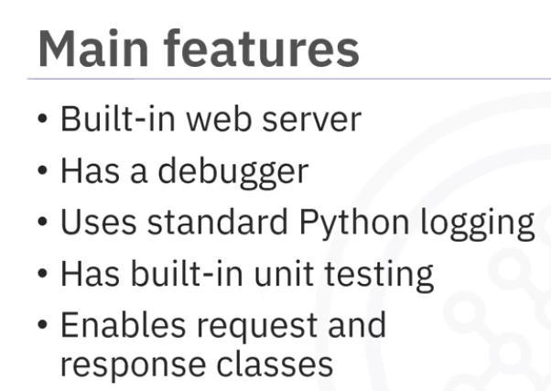

📝 Introduction to Flask — Notes

🔹 What is Flask?
- Flask is a micro web framework used to build web applications in Python.
- It is not opinionated → developers are free to choose tools and structure.
- Created by Armin Ronacher (2004) as an April Fool’s joke.
- Popular due to:
  - Simplicity
  - Flexibility
  - Extensibility

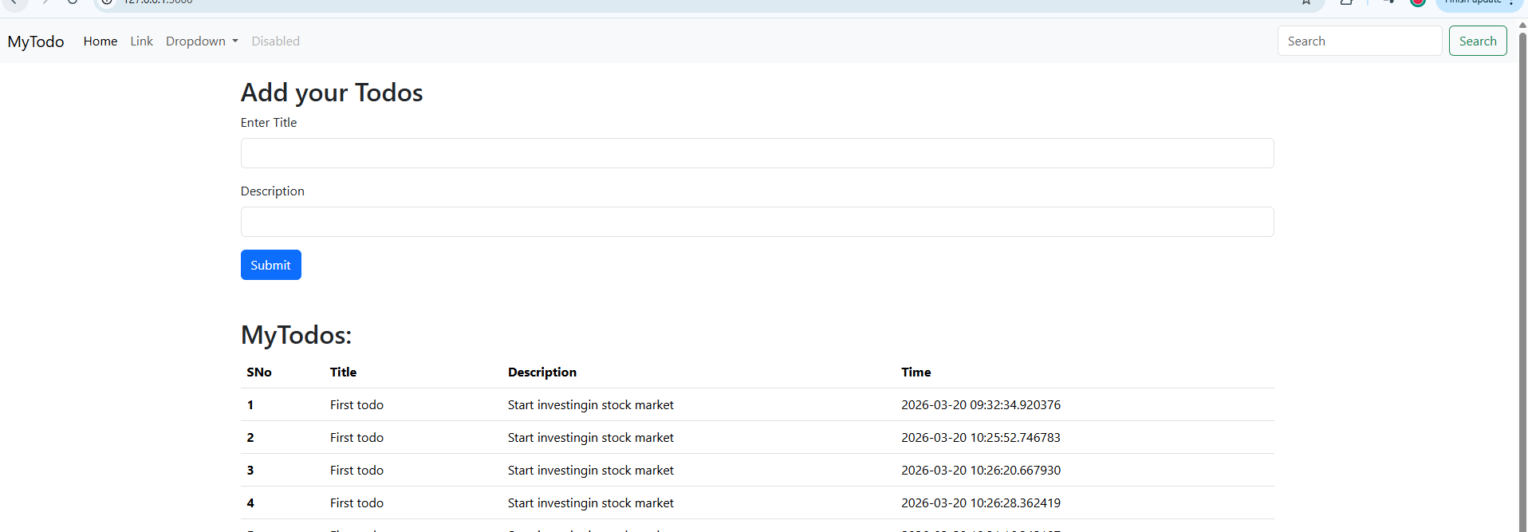
Talking to Database using Flask-SQLAlchemy (ORM):
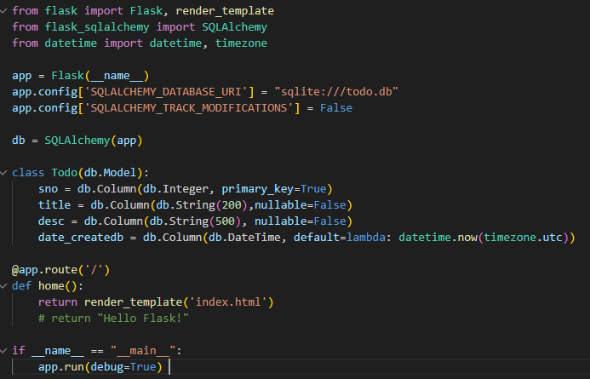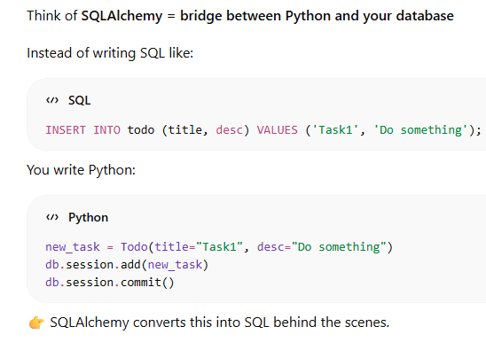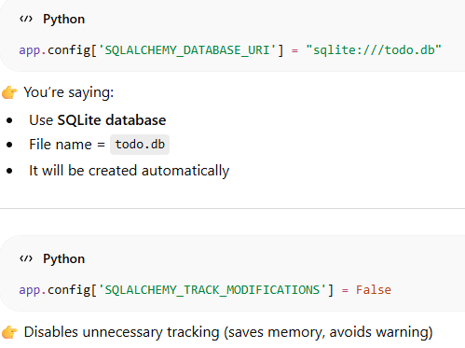
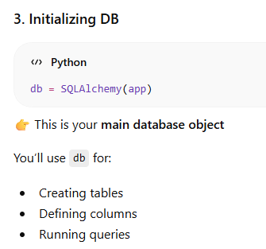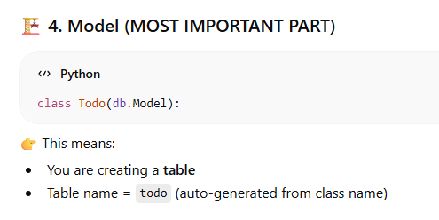
Now in order to create the db we do: 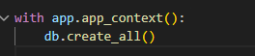. This will will create a 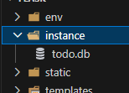. 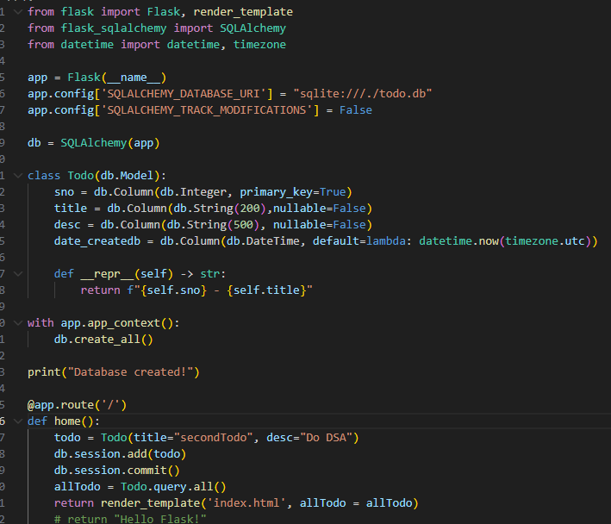
In order to put the data in this db we first make an instance of Todo class and define in it what all we have to pass then type 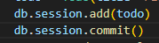. So it will ultimately look like this
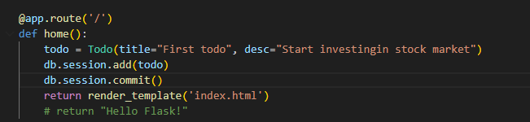… in the table.

In order to see the data that has been pushed in the html page you can do..(querying the records)
allTodo = Todo.query.all()
return render_template('index.html', allTodo = allTodo)
you can send the allTodo (basically records or a list that we got through the __repr__) to the index.html and we can use it there using jinja2.
<h1>All Users</h1>
{% for todo in allTodo %}
<p>{{ todo.title }} - {{ todo.desc }} - {{ todo.date_created }}</p> #notice here we are keeping the names same of the columns we described in our model
{% endfor %}
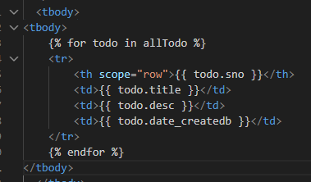-> in the index.html page
MOVING ON TO WORKING WITH FORMS..
Till now we were adding data through backend now we will do using the form that we have created in the index.html.
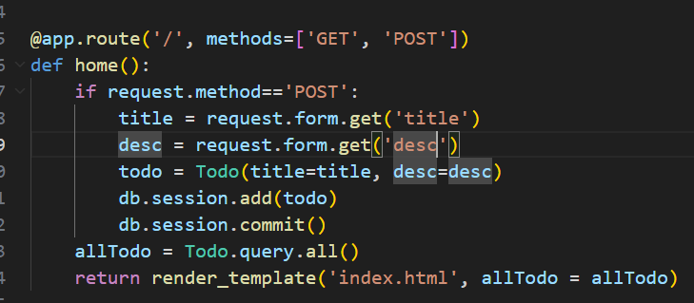
Initially browser sends GET / so block of code containing “if” will be skipped and page loads with existing Todos as allTodo = Todo.query.all()
When user fills form and click on submit, browser sends POST request with title and desc.
request.method == 'POST' ✅ (since now this is true this will not be skipped)
👉 request.form contains:
{
'title': 'MyTask',
'desc': 'Do DSA'
}

CRUD operation:
Create and read we have already done.
Delete:
